**資料庫管理系統**

第三次練習

|  |  |  |
| --- | --- | --- |
| 班級:資二乙 | 學號:3a632093 | 姓名:黃名廷 |
| 缺少: | 錯誤: |  |

目錄

學校School關聯式資料庫綱要 1

Create database 2

Create table 3

建立jobs 3

匯入資料 4

建立publishers 5

匯入資料 7

建立employee 8

匯入資料 10

在employee中練習輸入新進員工 11

驗證 12

建立計算欄位資料表 12

驗證 14

ER_Diagram 14

建立計算欄位資料表 15

驗證 16

Alter table 17

欄位 17

移除主鍵 17

增加主鍵 18

# 學校School關聯式資料庫綱要

Students ( sid, name, birthday, tel )

Parents ( sid, name, relationship )

Std-Address ( sid, address )

Results ( sid, e_no, grade, date )

Exams ( e_no, title, type, c_no )

Courses ( c_no, title, credits )

Instructors ( eid, department, rank, SSN )

Employees ( SSN, name, city, street, tel )

Classes ( eid, sid, c_no, time, room, grade )

# Create database

create database s3a632093

use s3a632093

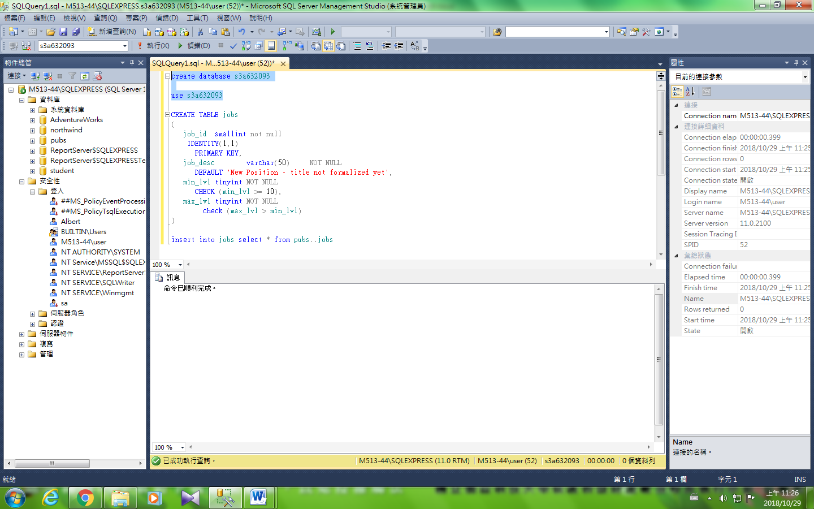

# Create table

本範例將示範已建立在s3a632093資料庫中的三個資料表(job、employee及publishers)的完整資料表定義，包含所有的條件約束定義

## 建立jobs

CREATE TABLE jobs

(

job_id smallint not null

IDENTITY(1,1)

PRIMARY KEY,

job_desc varchar(50) NOT NULL

DEFAULT 'New Position - title not formalized yet',

min_lvl tinyint NOT NULL

CHECK (min_lvl >= 10),

max_lvl tinyint NOT NULL

check (max_lvl >= 100)

)

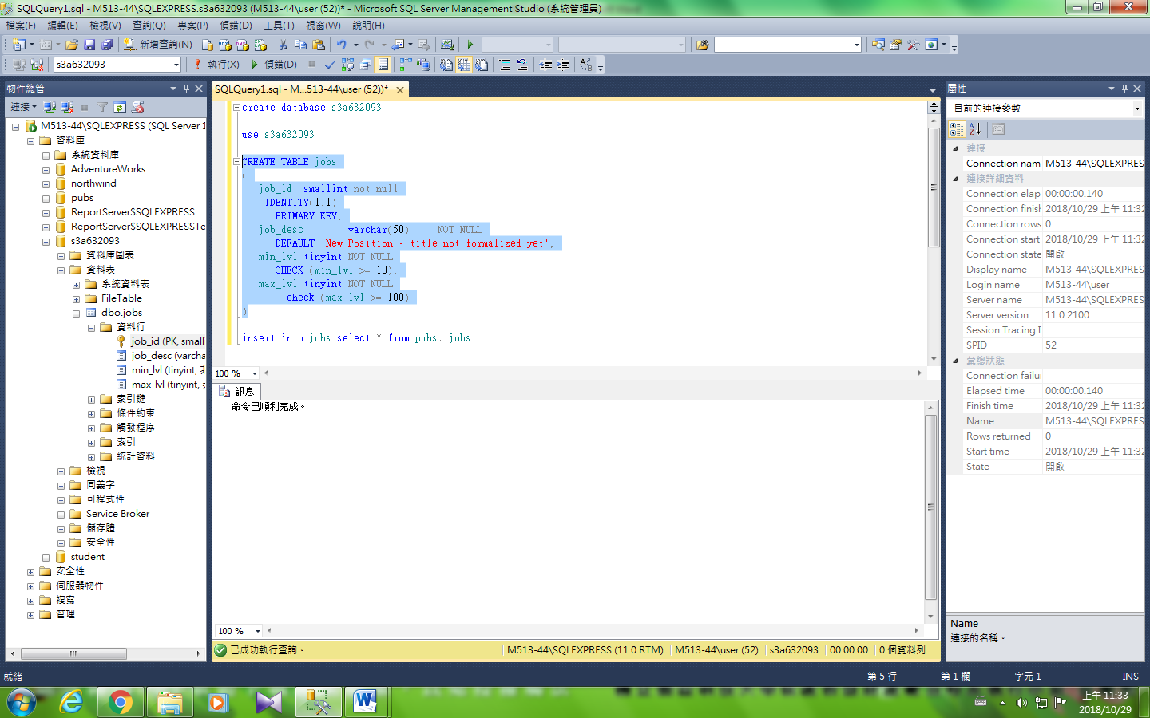

## 匯入資料

輸入資料庫pubs中的jobs

set IDENTITY_INSERT jobs on

go

insert jobs (job_id, job_desc, min_lvl, max_lvl) select * from pubs..jobs

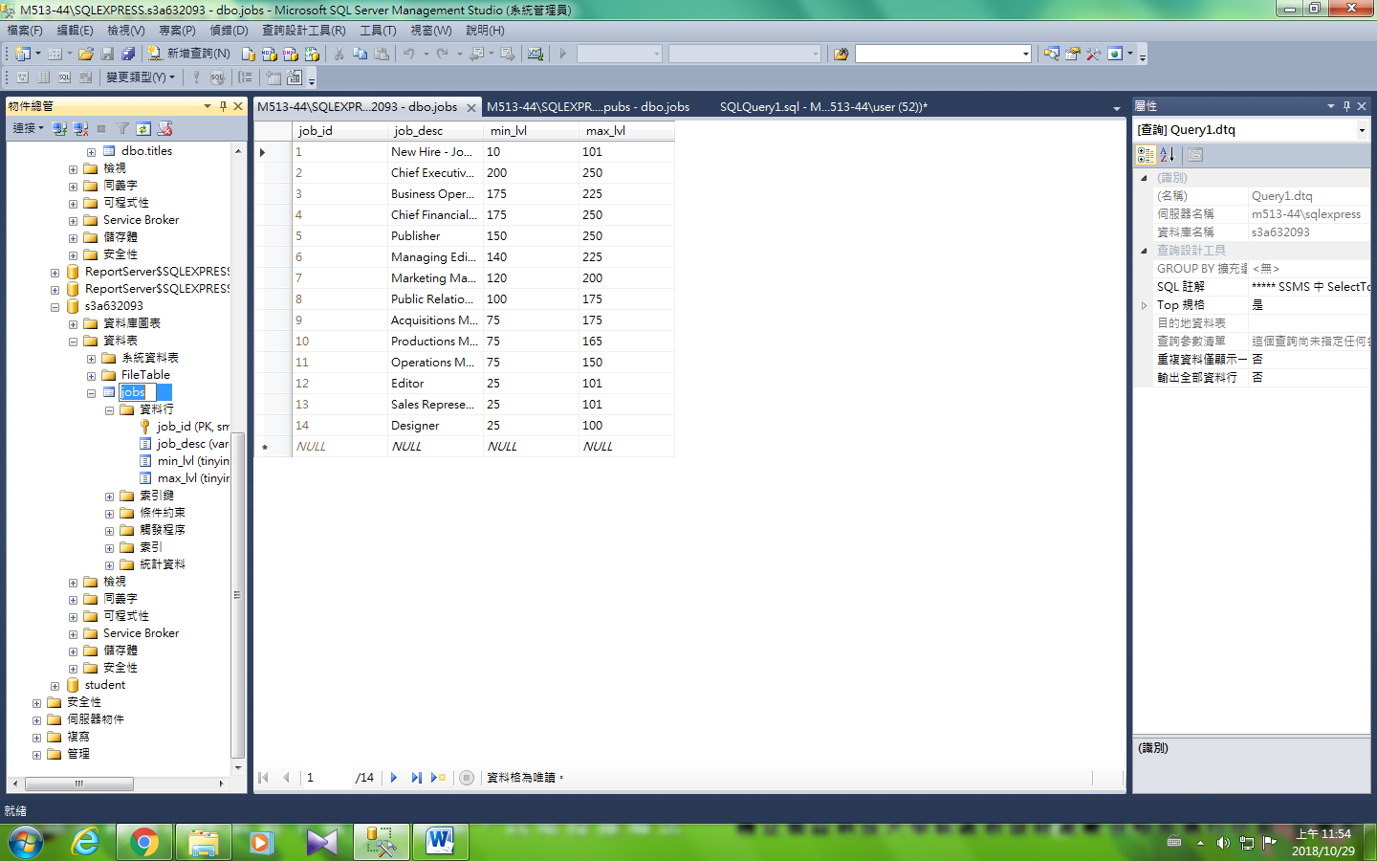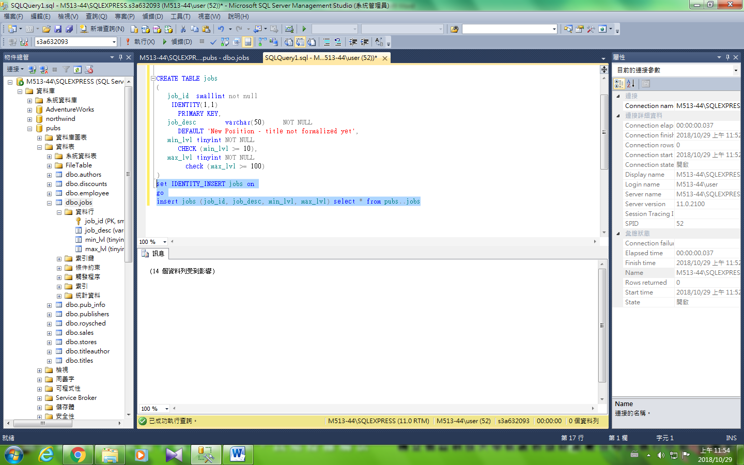

## 建立publishers

CREATE TABLE publishers

(

pub_id char(4) NOT NULL

CONSTRAINT UPKCL_pubind PRIMARY KEY

CHECK (pub_id IN ('1389', '0736', '0877', '1622', '1756')

OR pub_id LIKE '99[0-9][0-9]'),

pub_name varchar(40) NULL,

city varchar(20) NULL,

state char(2) NULL,

country varchar(30) NULL

DEFAULT('USA')

)

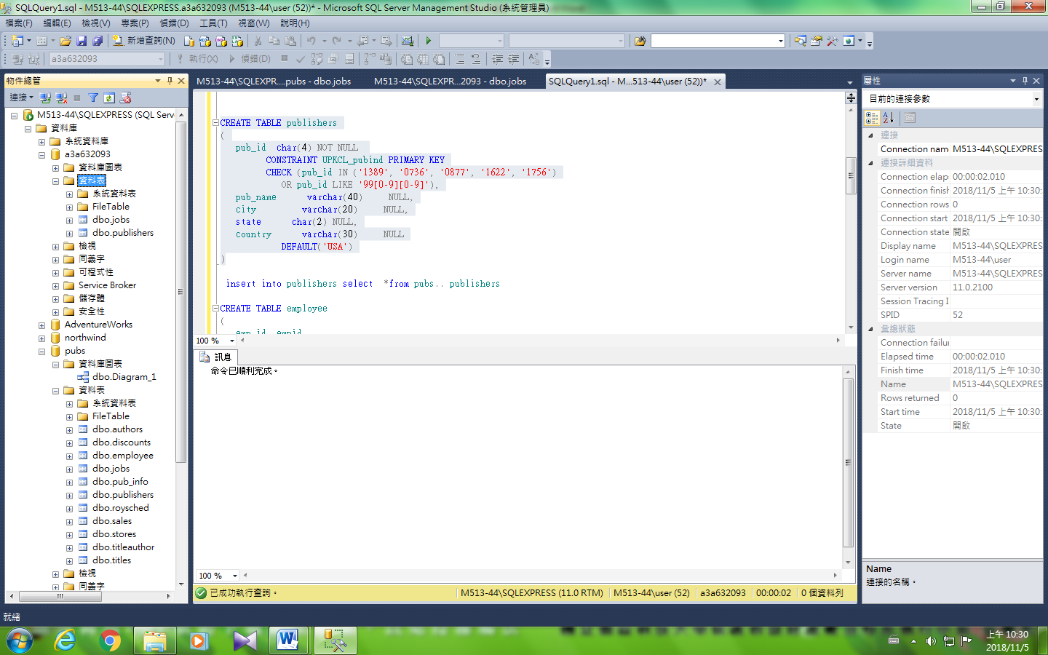

## 匯入資料

insert into publishers select *from pubs.. publishers

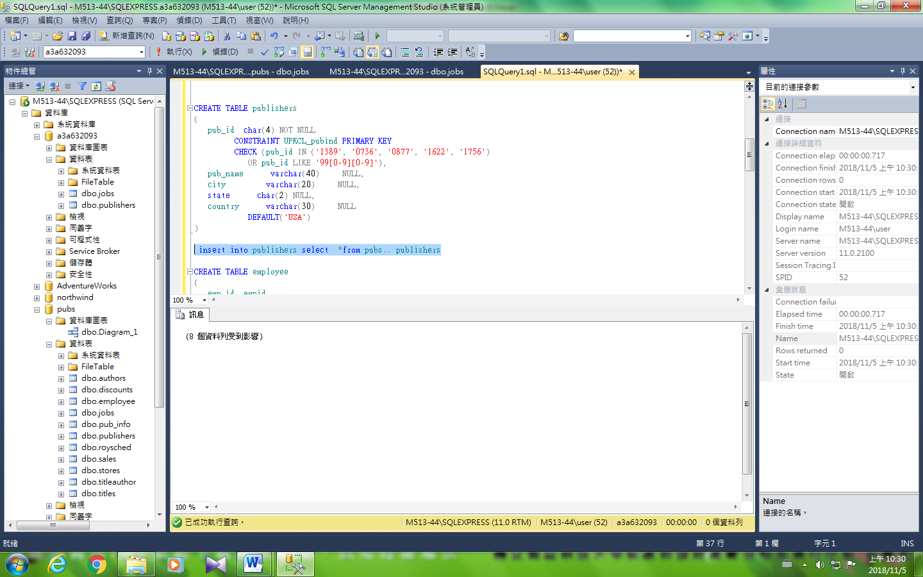

## 建立employee

sp_addtype empid, 'char(9)','null'

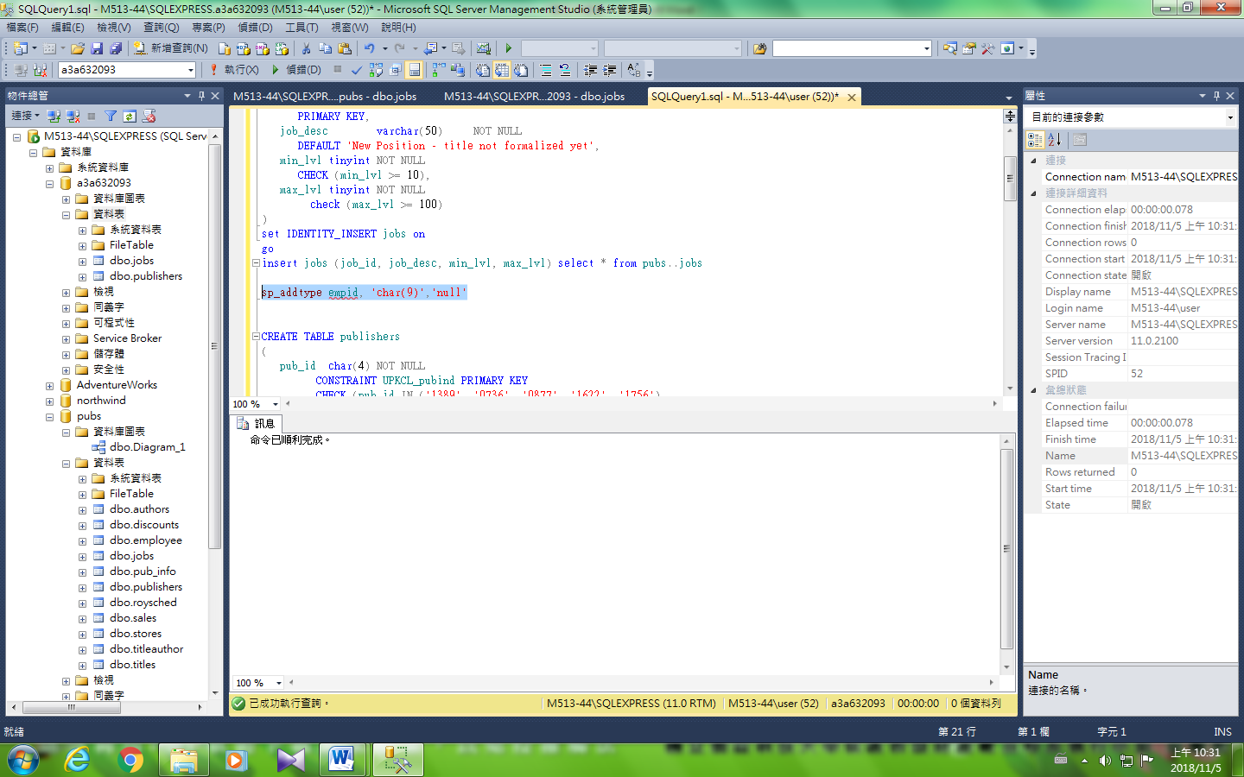

CREATE TABLE employee

(

emp_id empid

CONSTRAINT PK_emp_id PRIMARY KEY

CONSTRAINT CK_emp_id CHECK (emp_id LIKE

'[A-Z][A-Z][A-Z][1-9][0-9][0-9][0-9][0-9][FM]' or

emp_id LIKE '[A-Z]-[A-Z][1-9][0-9][0-9][0-9][0-9][FM]'),

/* Each employee ID consists of three characters that

represent the employee's initials, followed by a five

digit number ranging from 10000 through 99999 and then the

employee's gender (M or F). A (hyphen) - is acceptable

for the middle initial. */

fname varchar(20) NOT NULL,

minit char(1) NULL,

lname varchar(30) NOT NULL,

job_id smallint NOT NULL

DEFAULT 1

/* Entry job_id for new hires. */

REFERENCES jobs(job_id),

job_lvl tinyint

DEFAULT 10,

/* Entry job_lvl for new hires. */

pub_id char(4) NOT NULL

DEFAULT ('9952')

REFERENCES publishers(pub_id),

/* By default, the Parent Company Publisher is the company

to whom each employee reports. */

hire_date datetime NOT NULL

DEFAULT (getdate())

/* By default, the current system date is entered. */

)

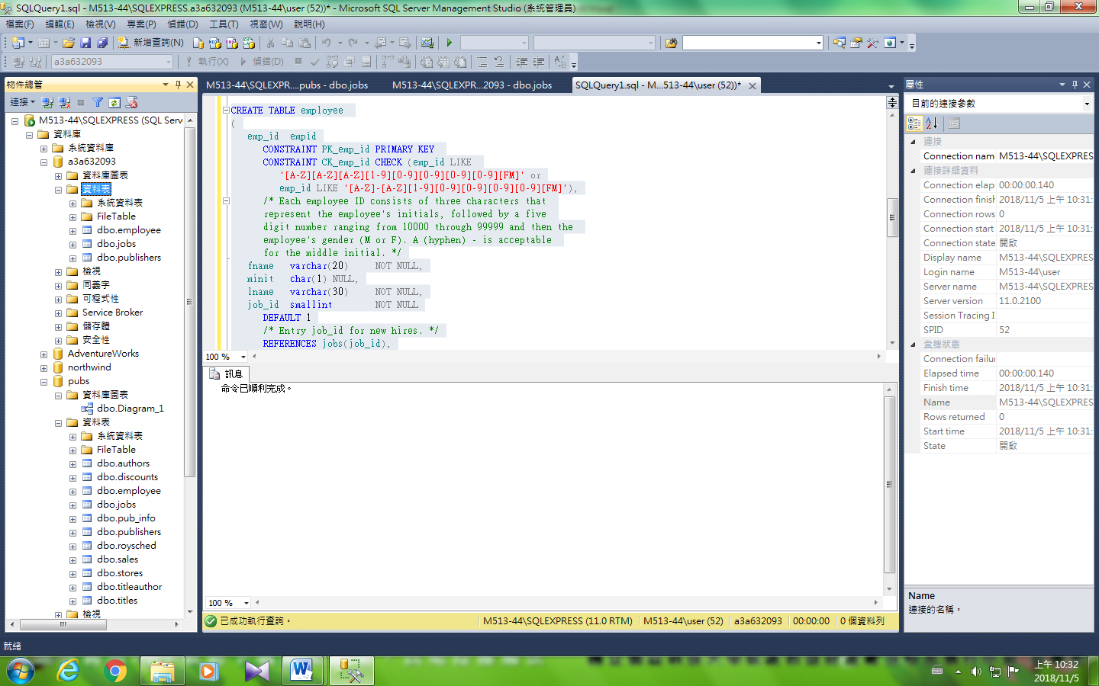

## 匯入資料

insert into employee select *from pubs.. employee

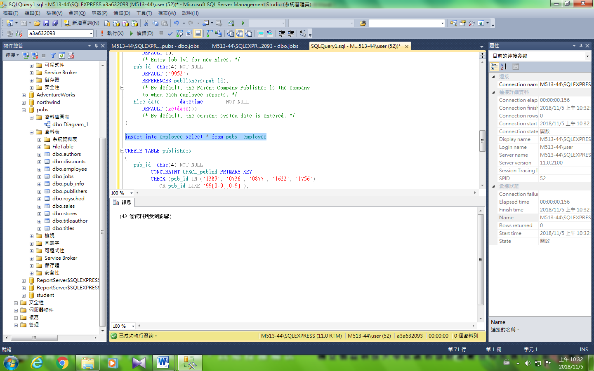

## 在employee中練習輸入新進員工

手動鍵入

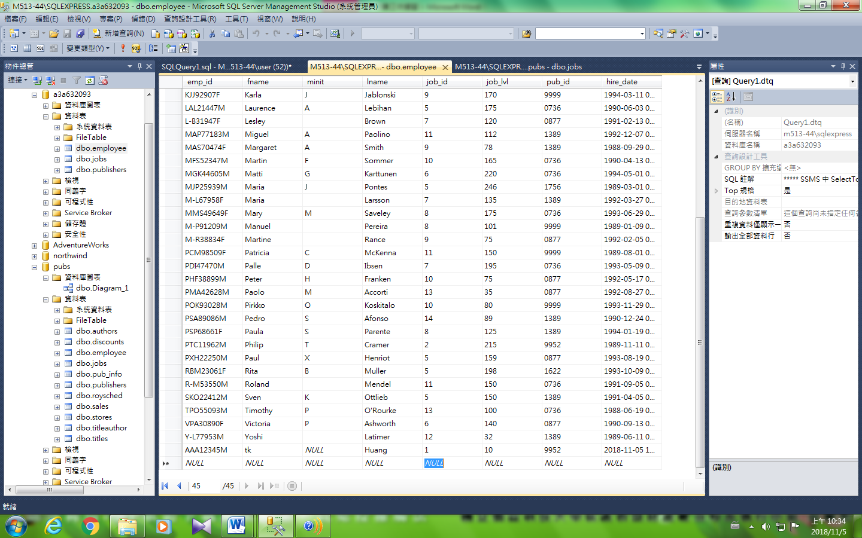

insert into輸入

insert into employee([emp_id],[fname],[lname]) values ('AAA54321M','王','翔')

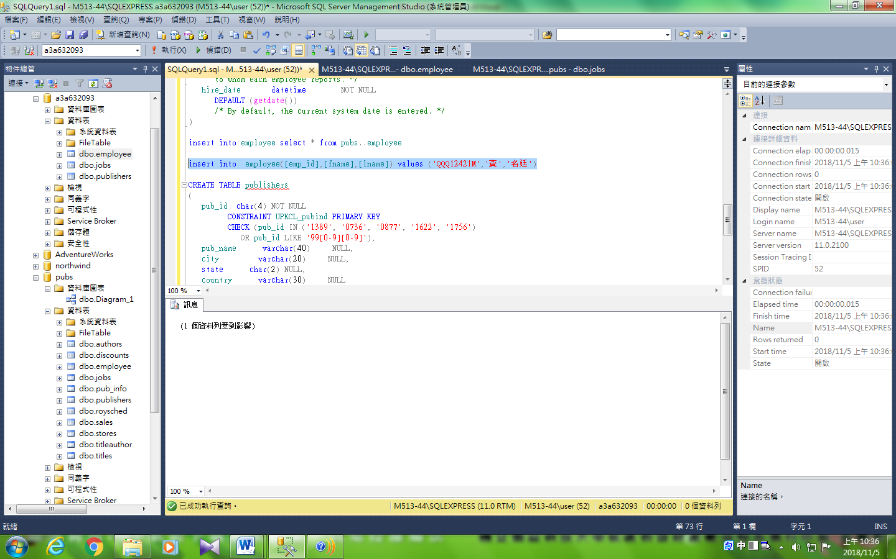

### 驗證

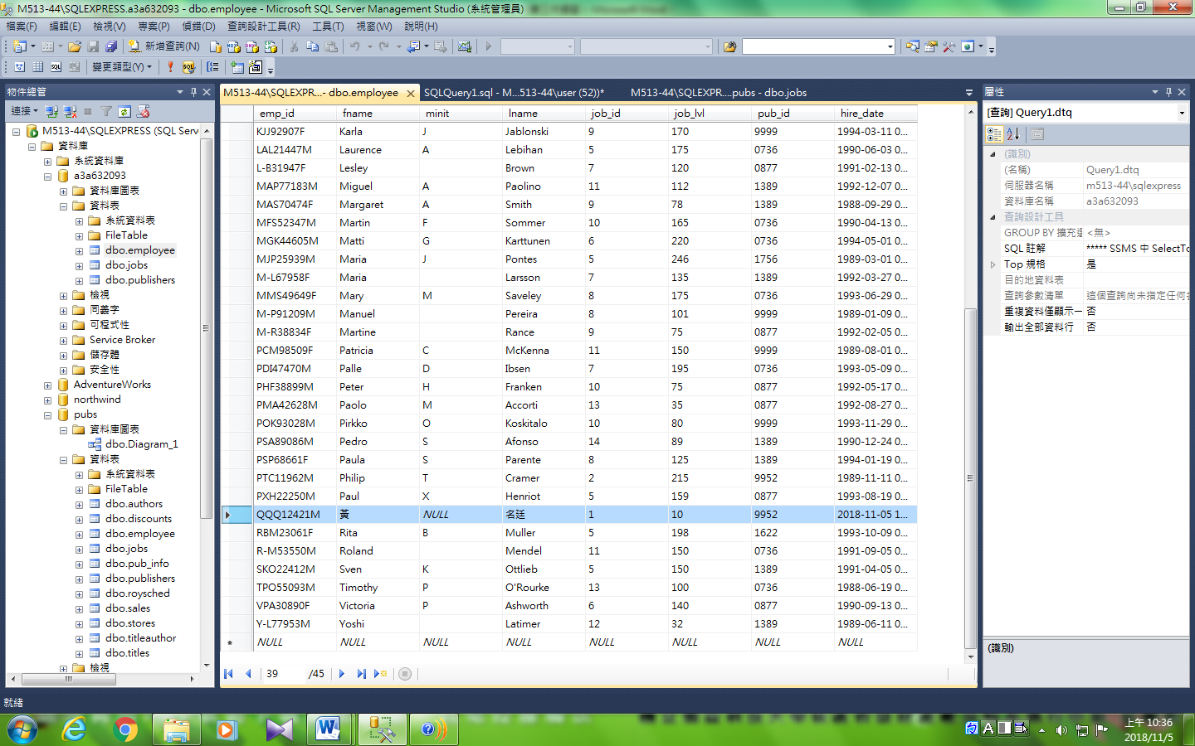

## 建立計算欄位資料表

CREATE TABLE mytable

(

[low] int,

high int,

myavg AS ([low] + high)/2

)

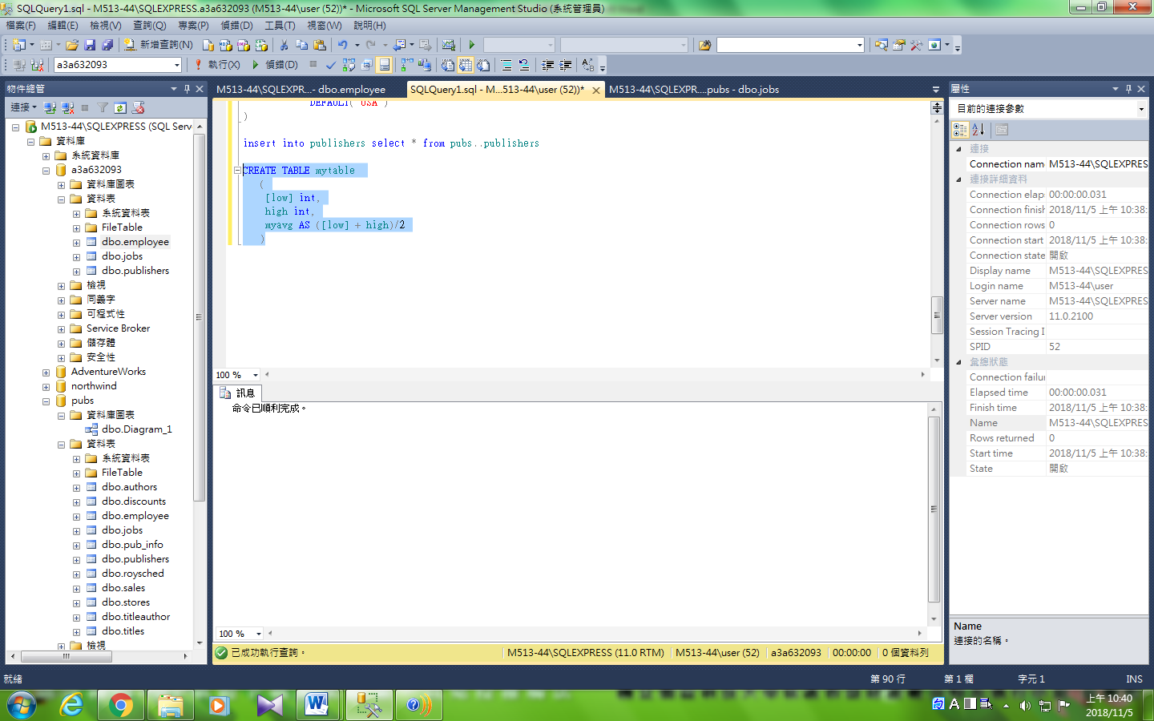

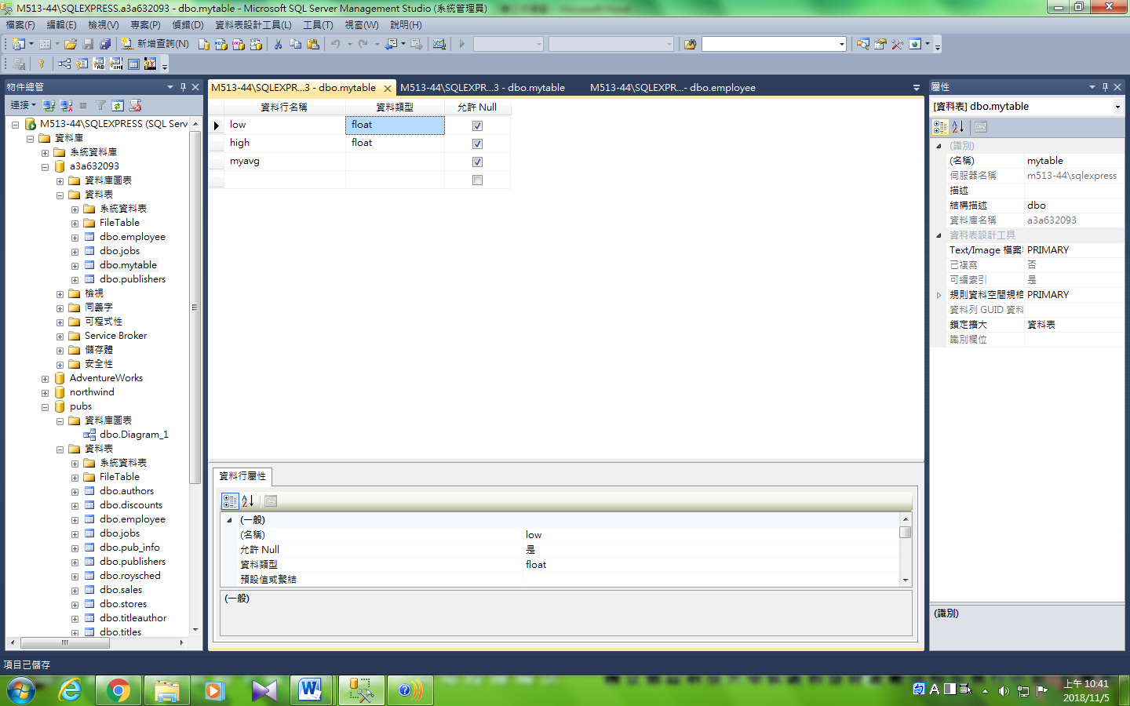

### 驗證

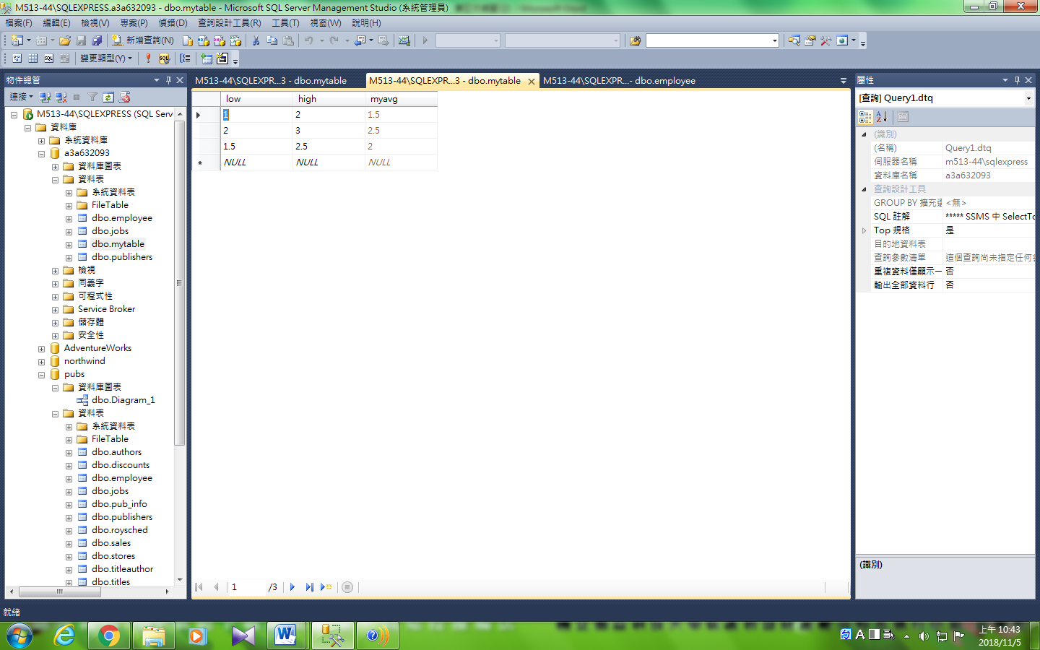

## ER_Diagram

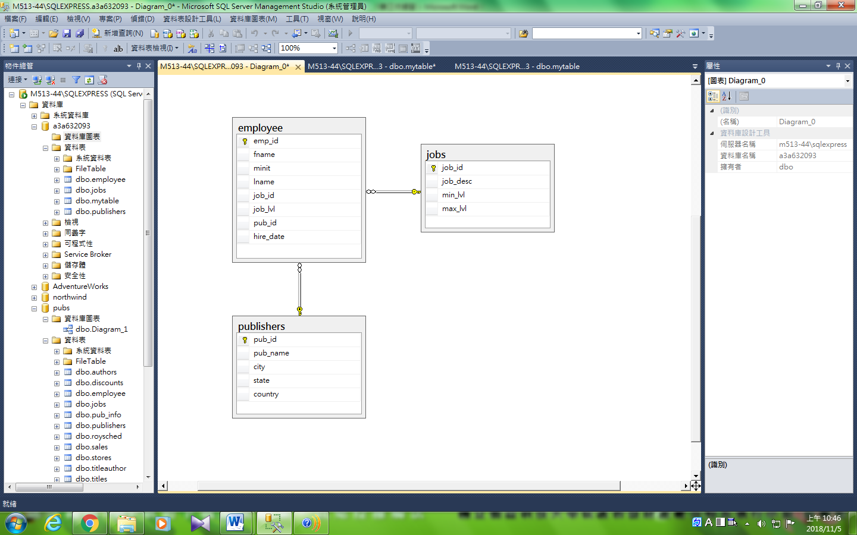

## 建立計算欄位資料表

CREATE TABLE 估價

( 編號 int IDENTITY,

單價 money,

數量 int,

總價 AS 單價 * 數量

)

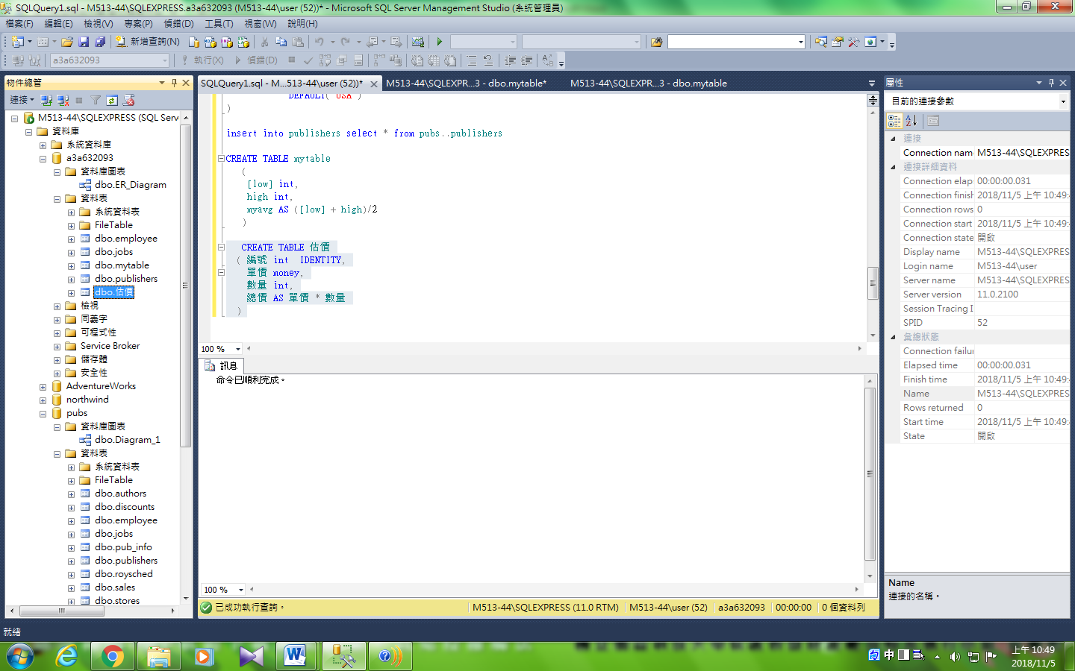

### 驗證

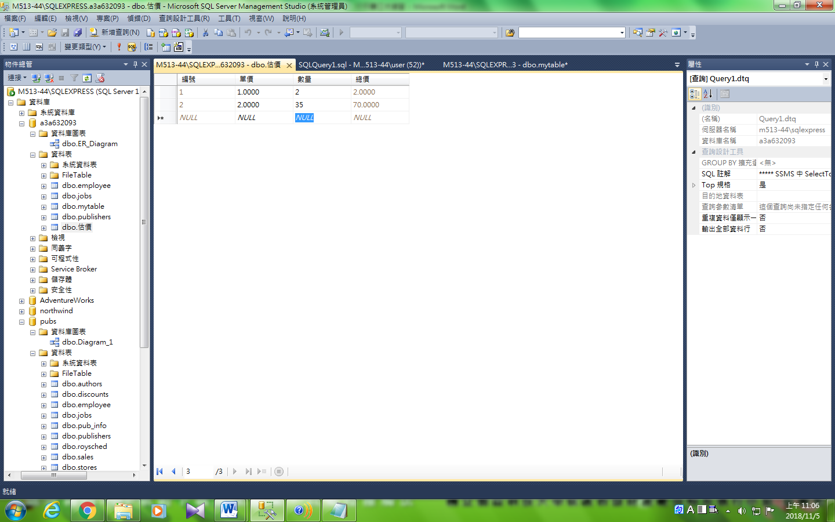

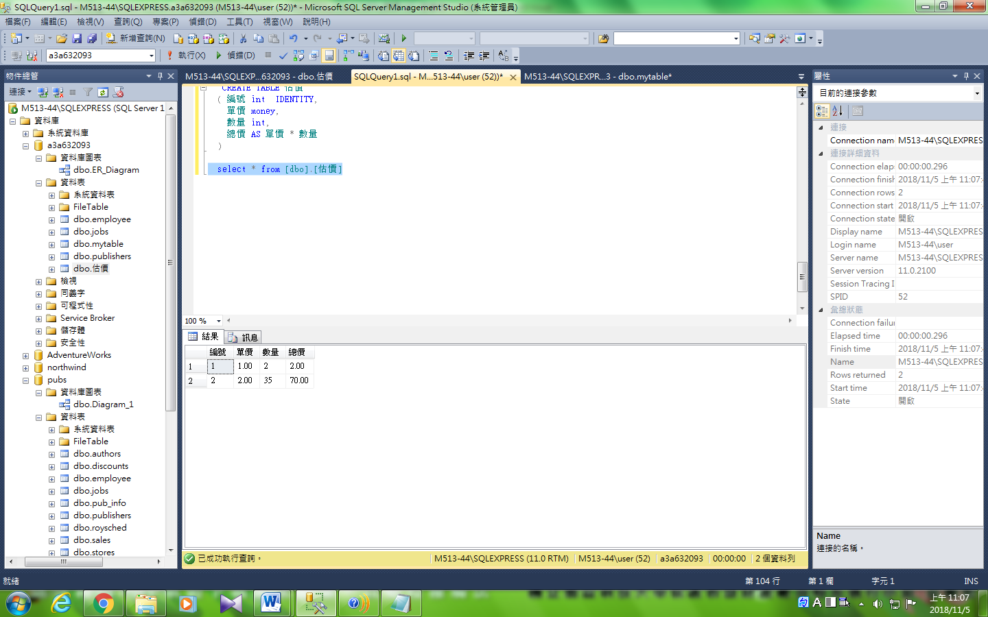

## Alter table

### 欄位

改變前

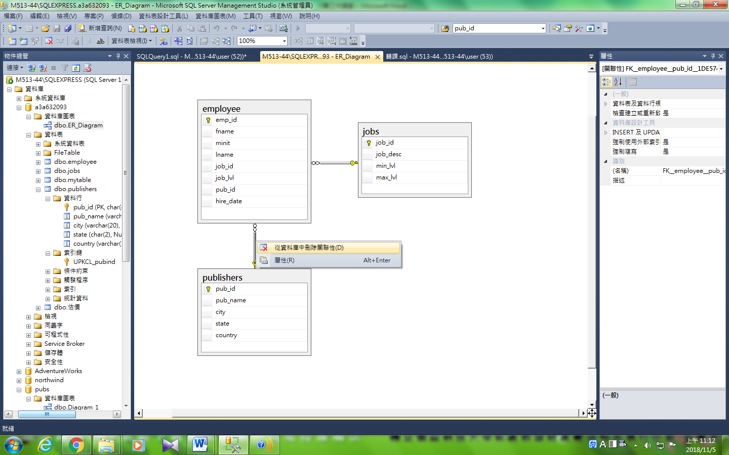

### 移除主鍵

ALTER TABLE [dbo].[publishers]

drop [UPKCL_pubind]

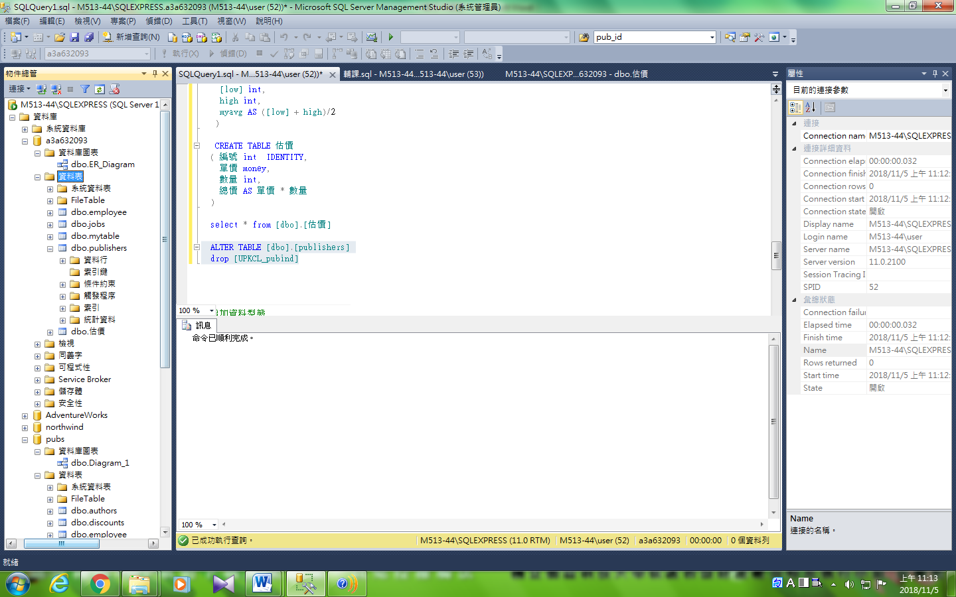

### 增加主鍵

ALTER TABLE dbo.publishers

ADD PRIMARY KEY (pub_id)

